➢➢ Explanation :
- We have a source block and a destination block. The source block contains N bytes. For
example : Let N = 10. We have to reverse this 10 bytes of data and transfer them to destination block.
- A pointer will be initialized to point to source block and another pointer to point the destination block. The count of number of bytes is loaded in the C register.
- We will add the count to source memory pointer, so that the source memory pointer will point to the last location. Then, we will copy the contents of this location to destination.
- Decrement the counter. Decrement Source memory pointer to point to (N – 1)^{th} block.
- Increment destination pointer to point to the next location.
- Repeat the process till all the contents are transferred to destination block in reverse manner. Store the result.
➢➢ Algorithm :
Step I : Initialize pointer to starting location of source and destination pointer to starting location of destination block.
Step II : Initialize C = count.
Step III : Source pointer = Source pointer + (count – 1), i.e. Source pointer points to last element in source block.
Step IV : Load A = contents of element where Source pointer is pointing.
Step V : Transfer contents of A to destination location.
Step VI : Decrement Source pointer.
Step VII : Decrement count.
Step VIII : Increment Destination pointer to next location.
Step IX : Check if count = 0 ? If not, go to step IV.
Step X : Display transferred contents.
Step XI : Stop.
➢➢ Flowchart : Refer flowchart 31.
➢➢ Program :
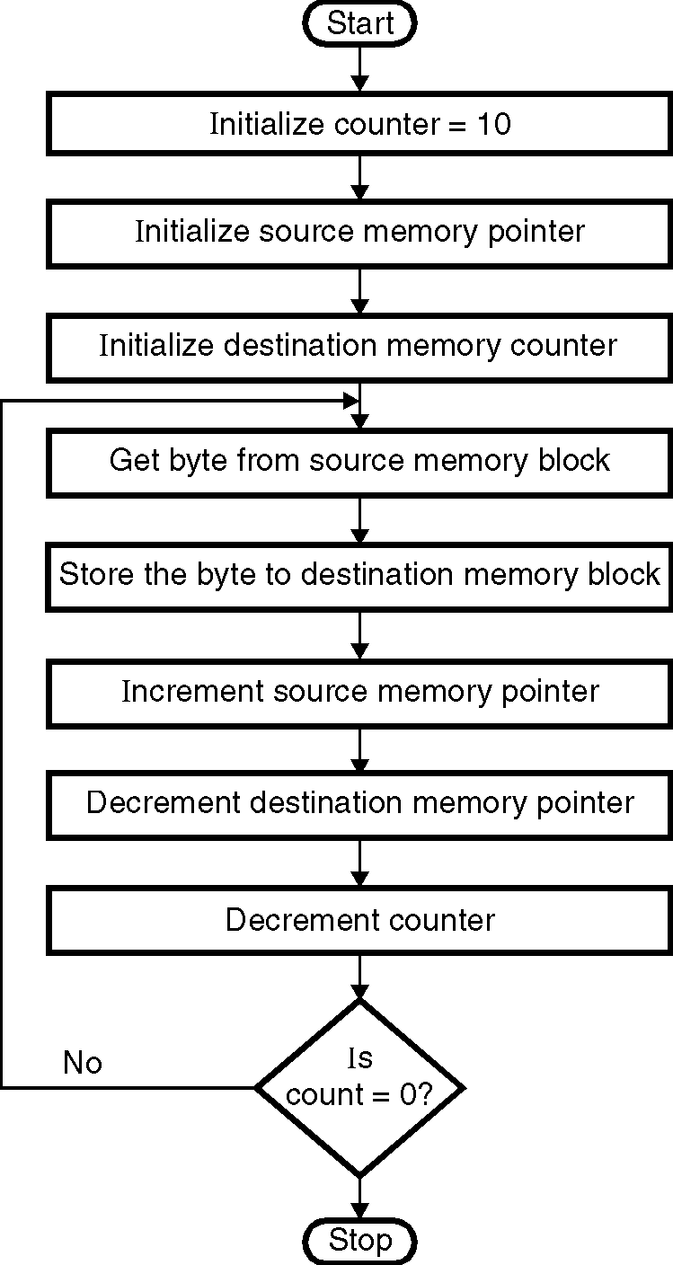
Instruction Comment
MVI C, 0AH ; Initialize counter
LXI H, D000 H ; Initialize source memory
; pointer
LXI D, D100 H ; Initialize destination
; memory pointer
BACK: MOV A, M ; Get byte from source
; memory block
STAX D ; Store byte in the destination
; memory block
INX H ; Increment source
; memory pointer
DCX D ; Decrement destination
; memory pointer
DCR C ; Decrement counter
JNZ BACK ; If counter 0 repeat
HLT ; Terminate program execution

Flowchart 31

